21.5inch capacitive touch kiosk

windows version
Tech specification

Catalogue

Product Description 2Display parameter 3
Touch parameters 3
System configuration 3
Basic function 4
Machine parameter 5
Electrical features 5
Packing list 5
Diagram 6
Product rendering 6

version | drawing | audit
21.5-windows10
Revised date | 2024-07-12

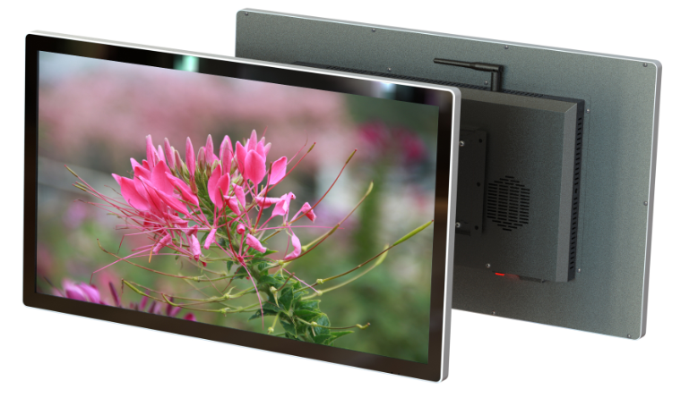
Product Description
◆ Appearance:All in one frame,super thin and beauty,install easily and maintain conveniently
- UHD：The use of IPS HD LCD panel, gorgeous color, high brightness, support 4K video, image decoding and playback, to achieve high-quality picture output display.
◆ Adopt high-channel capacitance G+G touch solution, smooth writing, precise touch and strong anti-interference.
◆ Intelligent:Equipped with intelligent Windows operating system, third-party client software can be installed.
- Scenarios：Widely used in government, education, finance, transportation, hotels, supermarkets, exhibition halls, medical, catering, enterprises and other industries.
◆High-end：beauty,UHD,easy to use,commercial use and intelligent etc.high-eng and popular.

Display parameter
Brand | QUNMAO
Model | QM-C22XJ-P
Screen Size | 21.5inch
Resolution | 1920*1080
Angle of view | 89/89/89/89
Contrast ratio | 1000：1
Display size | 476.5×268mm（H×V）
Display rate | 16:9
Back light | LED
Brightness | ≥250cd/m2
Refresh rate | 60HZ
Color | 16.7M(8-bit)

Touch parameters
Technology | Capacitive touch
touch scheme | G+G
Touch point | 20 points
Touch mode | Finger or touch pen
Touch accuracy | ≦2mm
Service life | 60 Million touch
Drive mode | drive-free

System configuration
Operation system |  | Windows10/11
Version |  | Intel i5/i7
RAM |  | 4G/8G/16G
SSD |  | 128G/256G/512G
nterface type |  | DC*1 USB*4 RJ45*1 Audio*1 VGA*1 HDMI*1
Android OS Optional
Operation system |  | Android
Version |  | 13.0
CPU |  | T972 Quad core A55，Main frequency up to 1.9GHz
GPU |  | Mali-G31
RAM |  | 2/4GB
Storage memory |  | 16/32GB
interface |  | HDMI*1(2.1 4kx2k@60Hz input) USB*2
Audio interface |  | 3.5mm ear jack*1
Network |  | 1pc，10M/100M Adaptive Ethernet
WIFI、BT |  | Built in WIFI（2.4G single-signal），BT4.2
3G/4G |  | Choose to install
Operation system | Windows10
Version | Intel i5/i7
RAM | 4G/8G
SSD | 128G/256G
RAM | DC*1 USB*4 RJ45*1 Audio*1 VGA*1 HDMI*1

Basic function
Telecommunication | Support WiFi+Ethernet, optional 3G/4G
Software Installation | Support installation of third-party APK
Self-start function | Support power-on auto-start
one-button start | Equipped with a one-button start switch (with light)
Set open close | Support custom power on/off time
Audio Features | Built-in two high-quality tweeters
Mouse Function | Support hot-swap of mouse and keyboard
Language Mode | English/Supports multiple languages
Video Decoding | Support 1080P video and picture decoding and playback

Machine parameter
Color | black, white, silver
Frame material | Aluminum profile
Body Material | Hardware cold-rolled steel plate (metal spraying)
Product size | 508.4*305*56.6mm (including wall mount)
Packing size | 545*355*100mm
Bracket | Universal for horizontal/vertical hanging
Packing material | Carton
Net/gross weight | 5KG/6KG
Wall bracket hole distance | 100*100mm
Install ways | mount-on wall/embedding/hang/bracket

Electrical features
Scenarios | indoor
Rated Voltage | AC110-220V
Stand by power | ≦1W
Rated power | ≦55W
Suitable Environment | Temperature ‐0℃~55℃/Humidity 10%RH~90%RH
Storage Environment | Temperature‐5℃~60℃/Humidity 10%RH~90%RH

Packing List
21.5inch capacitive touch kiosk | 1pc
Power cable | 1pc
Remote control | 1pc
WiFi antenna | 1pc
Warranty card | 1pc

Diagram

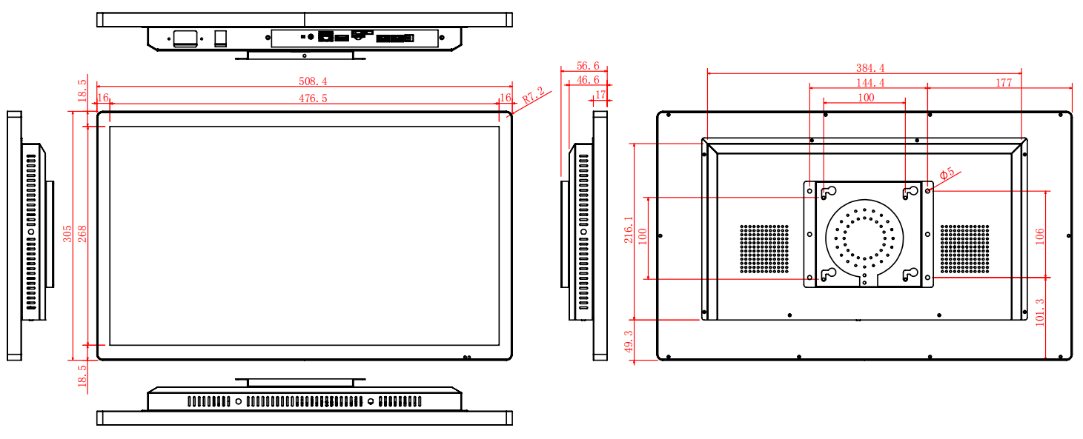

Product rendering
wall mounted | K type base
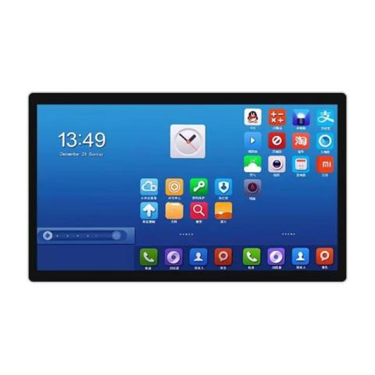 | 