55inch water-brand Digital Signage

Android version

Tech specification

Catalogue

Product Description 2
Display parameter 3
System configuration 3
System Function 4
Software function 4
Machine parameter 5
Electrical features 5
Packing list 5
Diagram 6

version | drawing | audit
55-Android-13.0
Revised date | 2024-07-28

Product Description

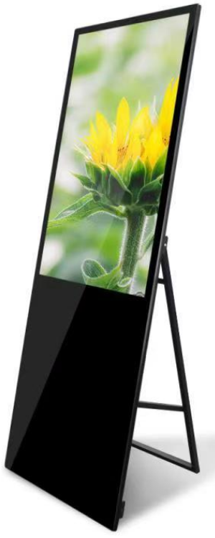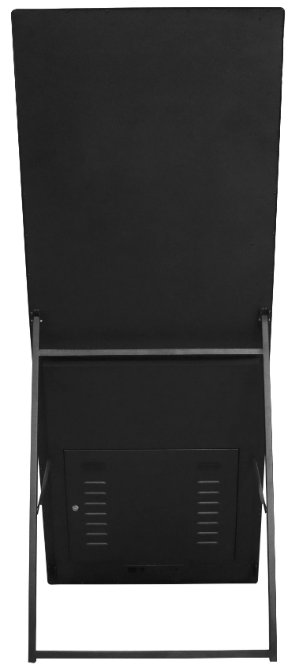

- Appearance: Adopt industrial structure design concept,All in one frame,super thin and beauty,install easily,maintain conveniently and unique cooling technology
- UHD：The use of IPS HD LCD panel, gorgeous color, high brightness, support 4K video, image decoding and playback, to achieve high-quality picture output display
- Intelligent:Equipped with intelligent Andorra operating system, pre-installed front-end presentation software and powerful
- Scenarios：Widely used in government, education, finance, transportation, hotels, supermarkets, exhibition halls, medical, catering, enterprises and other industries
- High-end：beauty,UHD,easy to use,commercial use and intelligent etc.high-eng and popular

Display parameter
Brand | QUNMAO
Model | QM-5516GL-S
Screen Size | 55inch
Resolution | 1920*1080/3840*2160
Angle of view | 89/89/89/89
Contrast ratio | 3000：1
Display size | 682.2*1211.4mm（H×V）
Display rate | 16:9
Back light | LED
Brightness | ≥300cd/㎡
Refresh rate | 60HZ
Color | 16.7M(8-bit)

System configuration
Operation system | Android
Version | 13.0
CPU | T972 Quad core A55，Main frequency up to 1.9GHz
GPU | Mali-G31
RAM | 2GB
Storage memory | 16GB
interface | HDMI*1(2.1 4kx2k@60Hz输入) USB*2
Audio interface | 3.5mm ear jack*1
Network | 1pc，10M/100M Adaptive Ethernet
WIFI、BT | Built in WIFI（2.4G single-signal），BT4.2
3G/4G | Choose to install
Pre-install software | Display software

System Function
Decoding Capability | Supports 4K video and picture decoding and playback
Software application | Support to install the third-party software
Language | Russian、English etc language
Boot Animation | Support to customize
Infrared remote control | Operate system by remote control
Audio function | Support left/right channel output,built-in double 8Ω/9.5W power amplifier
Power-on/off | Remote control/timing/network wake-up/self-start
System authorization | Allow root permission and customize software development
Mouse mode | support wired/wireless mouse or use keyboard
System update | Support local and remote upgrade
Play mode | Audio：MP3,WMA,WAV, APE, FLAC, AAC, OGG,M4A,3GPP etc
Play mode | Picture：JPG、BMP、PNG etc
Play mode | Video：AVI，rm，rmvb， MKV，WMV，MOV，MP4 etc
Typing | Standard Android keyboard as default,can install the third party typing
More functions | follow instruction manual/video or contact supplier

Software function
Background support | Web/mobile IE（local network/WAN）
Play mode | Networking/standalone
Play support | video、picture、subtitles、PPT、web、weather、clock etc mixture to play
Smart splicing | support custom playing modes to splice as setting
Timing function | support to set playing custom program in time period
Terminal administration | Administrator can create and modify account for level-to level  administration
More function | follow instruction manual/video or contact supplier

Machine parameter
Color | Silver/Black
Frame material | Aluminum (oxidized wire drawing)
Body material | Metal cold rolled steel plate (metal coating)
Surface material | 3mm tempered glass(physical)
Product size | 747.1*1895*21mm
Packing size | 2015*165*860mm
Packing material | Neutral carton
Net/gross weight | 56.5KG/60KG
Access lock | Maintain power and circuit board
Install ways | bracket

Electrical features
Scenarios | indoor
Rated Voltage | AC110-220V
Stand by power | ≦1W
Rated power | ≦85W
Suitable Environment | temperature‐0℃~55℃/ humidity10%RH~90%RH
Storage Environment | temperature‐5℃~60℃/humidity10%RH~90%RH

Packing list
55inch water-brand Digital Signage | 1pc
Power cable | 1pc
Remote control | 1pc
WiFi antenna | 1pc
Warranty card | 1pc

Diagram

