Product Specifications

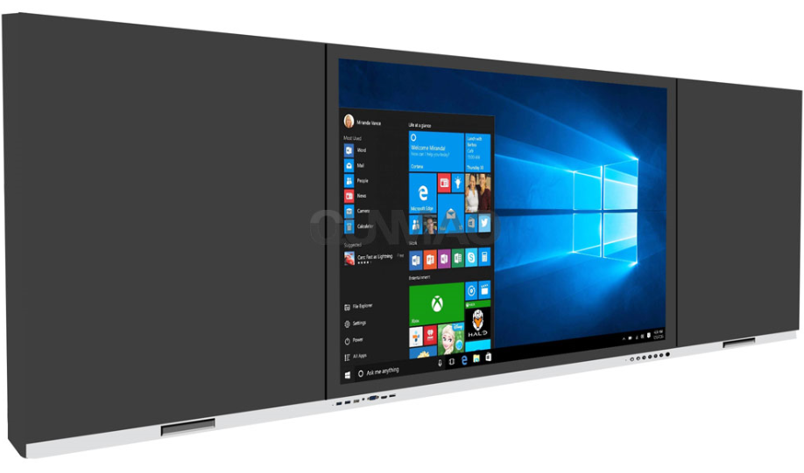

**1. Display parameters**

|  |  |
| --- | --- |
| Size | 98 inch |
| Visible area(mm) | 2158.84x1214.35 |
| Resolution | 3840 x 2160 |
| Proportion | 16:9 |
| Brightness | >350cd/m²(typ.) |
| Screen contrast | 4000:1 |
| Response time | ≤8ms (typ.) |
| Pixel pitch(mm) | 0.5622x0.5622 |
| Refresh rate | 60Hz |
| Life time | >30,000 hrs |
| Chromaticity | 1.07B |
| HDR | Support |

**2. Left and right blackboard**

|  |  |
| --- | --- |
| Category | Nano honeycomb board blackboard, support magnetic attraction function |
| Color | black |
| Quantity | Left x 1, Right x 1 |
| Size | Determined according to the size of the main display |
| Chalk slot | Support |
| Corner | Meet safety requirements |

**3. Touch parameters**

|  |  |
| --- | --- |
| Touch technology | Infrared/capacitance |
| Glass Specifications | 4mm tempered glass |
| Glass craft | Etching process |
| Input | Finger or capacitive pen |
| Maximum number of output points | 20 Points |
| Interpolation resolution | 32768(W) x 32768(D) |
| Touch accuracy | ≤2mm ，touch accuracy |
| Response time | ≤6ms |
| Transmittance | ≥82% |
| Haze | ≤2.5 |
| Surface hardness | ≥7H |
| Surface treatment | Anti-glare, anti-fingerprint |
| Touch diameter | Single Point≥1.6mm(Single touch ≥1.6mm) |
| Multi-point≥3mm(Multiple touch ≥3mm) |

**4. System parameters**

|  |  |
| --- | --- |
| Android version | Android 14.0 |
| CPU | Octa-core Cortex-A55 |
| GPU | Mali-G52*4 |
| （RAM） | 4/8GB |
| （ROM） | 32/128GB |
| OSD language | English/other |
| OPS | Windows10 11/i3 i5 i7/8+256G/16+512G |

**5. Horn**

|  |  |
| --- | --- |
| Position | Left and right channels: towards the front |
| Channel | 2.0 |
| Left and right channel audio power | 2×15W |

**6. WiFi Wireless & Wired Network**

|  |  |  |
| --- | --- | --- |
| Wired network | | Support 10/100Mbps |
| wireless WiFi | Standard | Built-in dual-channel WIFI, support AP hotspot |
| Protocol | Wifi ：802.11 b/g/n  AP ：802.11 a/b/g/n/ac |
| Working frequency | Wifi : 2.4GHz  AP : 2.4GHz/5GHz |
| Working distance | 0~12m |

**7. Bluetooth**

|  |  |
| --- | --- |
| Standard | Built-in |
| Version | 5.0 |
| Working frequency | 2.4GHz |
| Working distance | 0~12m |

**8. Camera (optional)**

|  |  |
| --- | --- |
| Standard | Built-in camera |
| Location | top, middle |
| Quantity | 1 |
| Pixel | 48million |
| Field of view FOV | Diagonal: 78°/ Horizontal: 63°/ Vertical 49° |
| Standard | Built-in microphone array |
| Location | lower border |
| Number of microphone arrays | >4, Voice range 0~8m |

**9. Physical booth (optional)**

|  |  |
| --- | --- |
| Optional | Support built-in physical booth |
| interface | USB2.0 |
| Size | 437.9mm*75.5mm*274mm |

**10. Electrical parameters**

|  |  |
| --- | --- |
| size | 98 inch |
| Voltage input | AC 100 ~ 240 V, 50/60 Hz |
| Maximum power (without OPS) | 550W |
| Standby power | <0.5W |
| Energy efficiency rating(CEL) | Level 1 |

**11. Indicators & Buttons**

|  |  |  |
| --- | --- | --- |
| indicator light | Location | front |
| color | red、blue |
| button | Location | front |
| quantity | 7 buttons + recessed jack |

**12. I/O Terminals**

|  |  |  |
| --- | --- | --- |
| Position | Terminal | Quantity |
| Front | USB3.0 | 2 |
| Type C | 1 |
| Touch USB | 1 |
| HDMI in | 1 |
| Rear | COAXIAL Out | 1 |
| RS232 | 1 |
| USB 2.0 | 1 |
| USB 3.0 | 1 |
| Touch USB | 1 |
| TF Card | 1 |
| LAN IN | 1 |
| MIC IN | 1 |
| HDMI IN | 1 (Optional 2PCS) |
| PC Audio IN | 1 (Optional) |
| LAN OUT | 1 (Optional) |
| DP | 1 (Optional) |
| HDMI OUT | 1 (Optional) |
| VGA | 1 (Optional) |
| 2.1 Chanel | 1 (Optional) |

**13. Dimensions and weight (subject to actual conditions)**

|  |  |
| --- | --- |
|  | 98” |
| Overall size (length × width × thickness) mm | 4500x94x1370.29 net weight 162Kg |
| Packing size (length x width x height) mm | 2459x303x15421265x330x1517 Gross weight 190Kg |

**14. Accessories**

|  |  |
| --- | --- |
| Left and right sub-boards | Left 1, Right 1 |
| remote control | 1 |
| Battery | 2 |
| power cable | 1（2 meter ） |
| Stylus | 1 |
| user's Guide | 1（Including warranty card and certificate） |
| wall mount | 1（Including wall mounting screws and installation instructions） |
| water soluble chalk | 1 box |

**15. Environmental factors**

|  |  |
| --- | --- |
| Operating temperature | 0℃~40℃ |
| Working humidity | 10%~85%RH |
| storage temperature | -20℃~60℃ |
| Storage humidity | 10%~90%RH |

