65 inch outdoor vertical digital signage

Android version
Tech specification

Catalogue

Product Description 2
Display parameter 2
Touch parameters（Optional） 3
System configuration 3
System Function 3
Software function 4
Machine parameter 4
Electrical features 5
Packing list 5
Diagram 5

version | drawing | audit
65-Android-13.0
Revised date | 2024-07-29

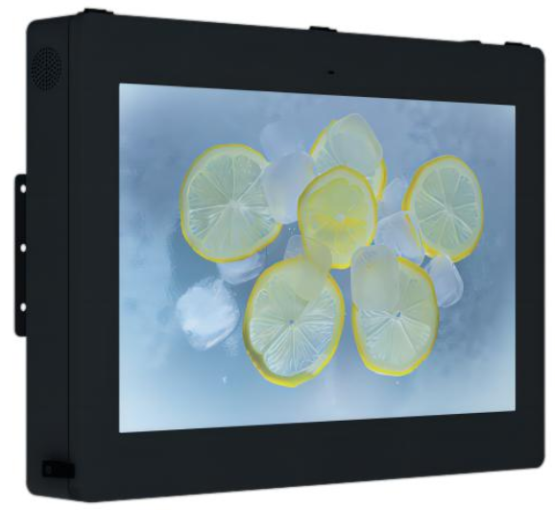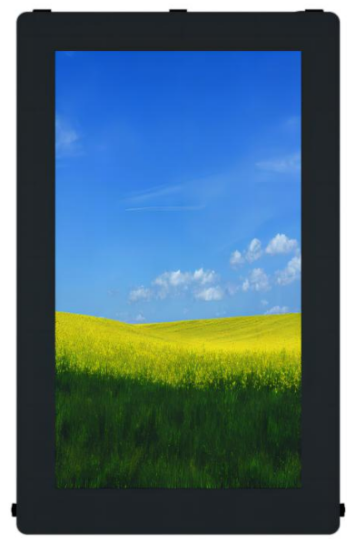

Product Description
- Structural design: the shell is made of 1.0-2.5mm high-quality galvanized sheet, sprayed with outdoor special powder, and the outdoor anti-corrosion is more than 7 years.
- Waterproof design: the shell structure is designed with waterproof groove and waterproof labyrinth of air inlet and outlet holes, meeting the protection level of IP65.
- Dustproof design: The air inlet and outlet are designed with special dust-proof filter (medium and high efficiency dust-proof filter) to filter the fine dust in the air and prevent mosquitoes from entering the device.
- Anti riot glass: 6mm high permeability fully tempered glass is used as the protective tempered glass in front of the screen of the whole machine, with the light transmission coefficient ＞ 95%.
- Anti theft design: equipped with anti-theft door lock (padlock can be added, double anti-theft) to truly achieve anti-theft security. The fixing method is to fix the bottom expansion screw or embedded parts.
- High brightness, with air cooling system, and multi split screen display mode.

Display parameter
Brand | QUNMAO
Model | QM-6518HW-L
Screen Size | 65inch
Resolution | 1920*1080/3840*2160（Optional）
Angle of view | 178°/178°
Contrast ratio | 3500：1
Display size | 803(H) x1428(V)mm
Display rate | 16:9
Back light | LED
Brightness | ≥2500cd/㎡
Refresh rate | 60HZ
Color | 16.7M(8-bit)
Response time | 6ms
Life span | 50000h
Smart photosensitive | The intensity of outdoor light automatically adjusts the brightness of the LCD display screen

Touch parameters（Optional）
Technology | Capacitive touch
Touch point | 20 points
Touch mode | Finger or touch pen
Touch accuracy | ≦2mm
Service life | 60 Million touch
Drive mode | Driver-free
Camera | 500MP

System configuration
Operation system | Android
Version | 13.0
CPU | T972 Quad core A55，Main frequency up to 1.9GHz
GPU | Mali-G31
RAM | 2GB
Storage memory | 16GB
Interface | HDMI*1(2.1 4kx2k@60Hz input) USB*2
Audio interface | 3.5mm ear jack*1
Network | 1pc，10M/100M Adaptive Ethernet
WIFI、BT | Built in WIFI（2.4G single-signal），BT4.2
3G/4G | Choose to install

System Function
Decoding Capability | Supports 4K video and picture decoding and playback
Software application | Support to install the third-party software
Language | Russian、English etc language
Boot Animation | Support to customize
Infrared remote control | Operate system by remote control
Audio function | Support left/right channel output,built-in double 8Ω/15W power amplifier
Power-on/off | Remote control/timing/network wake-up/self-start
System authorization | Allow root permission and customize software development
Mouse mode | support wired/wireless mouse or use keyboard
System update | Support local and remote upgrade
Play mode | Audio：MP3,WMA,WAV, APE, FLAC, AAC, OGG,M4A,3GPP etc
Play mode | Picture：JPG、BMP、PNG etc
Play mode | Video：AVI，rm，rmvb， MKV，WMV，MOV，MP4 etc
Typing | Standard Android keyboard as default,can install the third party typing
More functions | follow instruction manual/video or contact supplier

Software function
Background support | Web/mobile IE（local network/WAN）
Play mode | Networking/standalone
Play support | video、picture、subtitles、PPT、web、weather、clock etc mixture to play
Smart splicing | support custom playing modes to splice as setting
Timing function | support to set playing custom program in time period
Terminal administration | Administrator can create and modify account for level-to level  administration
More function | follow instruction manual/video or contact supplier

Machine parameter
Color | black white
Body Material | Using 1.2-2.5mmSGCC high-quality galvanized steel plate
Protection grade | IP65
Protective glass | 6mm explosion-proof glass (AG anti-glare/AR anti-ultraviolet optional)
Cooling by design | Intelligent direct ventilation (forced air cooling) heat dissipation system
Energy saving | Intelligent temperature control cooling system automatically adjusts wind speed and volume
dust proof | High-precision filtration system blocks 99% of dust particles
Product size | 940*2100*135mm(with base)
Base size | 940*500*60mm
Packing size | 2180*250*1080mm
Bracket | Universal for horizontal/vertical hanging
Packing material | Carton
Net/gross weight | 115KG/117KG
Install ways | mount-on wall/embedding/hang/bracket

Electrical features
Scenarios | outdoor
Rated Voltage | AC110-220V
Rated power | ≦100W-450W
Suitable Environment | -20℃ to +55℃ outdoor environment operation
Time switch | Support 16 groups of timed on/off, repeatable settings, timed on/off by day, week, month
Lightning protection | Level 3
Leakage protection switch | Disconnect the circuit promptly when leakage occurs

Packing List
65inch outdoor vertical digital signage | 1pc
Power cable | 1pc
Remote control | 1pc
WiFi antenna | 1pc
Warranty card | 1pc

Diagram
